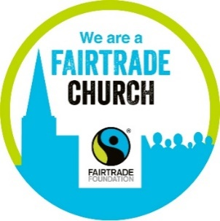
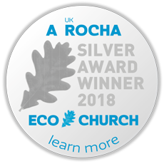

Eco Church News September 2026

St Mark’s Clothing Exchange - Tuesday 22 September 10 - 12, church hall

During Holbrook Heart Café, free, good clothes for children and adults. More info.


Western Sussex Rivers Trust Quiz - Friday 25 September 7.30pm, Holbrook Club

Karen Park is a River Guardian for Western Sussex Rivers Trust, monitoring the water and wildlife in Channels Brook where it flows past St Mark's. Fellow River Guardians are organising a Fun Quiz. Register a team, up to 6 people office@theholbrookclub.co.uk or contact Karen to join her team. £2 cash entry per person, on the night. Cash only raffle.

Community Fridge Pop-Up at St Mark’s - Saturday 24 October 10 - 11am

St Mark’s Autumn Clean or Garden - Monday 2 November

Deep cleaning the church or autumn gardening. Come along for an hour to help us!

Holbrook Community Autumn Litter Pick - Tuesday 17 November 9.30 - 11.30am

Refreshments at Holbrook Heart Café 10 - 12. Joint North Horsham Parish Council event.

Recycle batteries, vapes, electrical and electronic equipment safely

Help prevent the increasing number of fires in waste collection vehicles and sorting centres, so many things now have batteries, including toys and some shoes!
https://www.westsussex.gov.uk/campaigns/dont-let-your-old-electricals-start-a-revolt

St Mary's Parish Eco Church Day & People’s Emergency Briefing - 26 September

Celebrating our care of God's creation and Fairtrade Fortnight. 10am – 3pm.

Morning all age activities in The Barn and churchyard including: bulb planting, guided prayer walk, bee-keeping demonstrations and Horsham Men's Shed stall.

Bring a picnic, Fairtrade refreshments will be served.

People's Emergency Briefing film - 1pm, The Barn

- Age 16+ followed by facilitated discussion & refreshments

- Film Trailer & Nationwide Screenings Map https://www.nebriefing.org

- Please sign up for the morning's activities, the film or both, 'add an additional ticket' to sign up to both.
https://horshamteamparish.
churchsuite.com/events/9m7pkeeq

Horsham Eco Churches September News

Includes Climate Feelings, Going for Gold, Sussex Green Hub, West Sussex Climate Survey, Tearfund Climate Crisis Action, Living Water and much more! https://tinyurl.com/HEC-News

Help St Mark’s Achieve a Gold Eco Church Award stmarksholbrook.org.uk/EcoChurch
Contact St Mark’s Eco Church Champion, Karen Park ecochurch@stmarksholbrook.org.uk

